PROJECT REPORT

On

**Virtual Assistant**

*Submitted in partial fulfillment for the award of the degree* Of

**BACHELOR OF TECHNOLOGY**

In

**COMPUTER SCIENCE AND ENGINEERING**

By

**AKANKSHA**

**KAJAL GARG**

**SHIKHA DUBEY**

Under the Supervision of

**Dr. AMITA MALIK** (Associate Professor, CSED)



DEPARTMENT OF COMPUTER SCIENCE AND ENGINEERING

Deenbandhu Chhotu Ram University of Science and Technology,

Murthal, Sonepat-131039

2018

**DECLARATION**

We hereby declare that the project entitled **“Virtual Assistant”** submitted by us in partial fulfillment of the requirement for the award of BACHELOR OF TECHNOLOGY Degree in COMPUTER SCIENCE AND ENGINEERING, comprises our original work and due references have been made in text to all other materials used.

*AKANKSHA (14001001041)*

*KAJAL GARG (14001001026)*

*SHIKHA DUBEY (14001001050)*

Place: DCRUST, Murthal

Date:

I

**CERTIFICATE**

This is to certify that the project entitled “**Virtual Assistant**” is the bonafide work carried out by AKANKSHA (14001001004), KAJAL GARG (14001001026), SHIKHA DUBEY (14001001050) students of Final year B.Tech. (CSE) DCRUST, Murthal, during the year 2018, in partial fulfillment of the requirements for the award of the Degree of Bachelor of Technology.

**Dr. Amita Malik**

Place: DCRUST, Murthal

Date:

II

**ABSTRACT**

**CounsellingAssistant** is a web portal which is developed and implemented on java domain or platform. This project assists the process of Physical Counselling through an online portal. In current times, everything is going online. This project will help students and teachers to exchange information for the efficient and controlled flow of the Counselling process.

Further, it will also reduce the manual efforts and delays in the process. **CounsellingAssistant** is implemented in 6 modules Registration/Authentication Module, Form Filling Module, Attendance Module, Document Verification Module, Seat Allotment Module and Final Enrollment Module . Registration/Authentication Module registers the candidates who want to apply for the Counselling Process. The second module , comprises of form filing.Following the second module , the registered candidates are mailed a list of documents and the details of the counselling process. The third module is the initiation of the actual counselling process taking into action. It marks the attendance of the candidates who have enrolled and are present for the counselling process. These details are then sent further to the Document Verification Module. The interface automatically arranges the students in a rank-wise pattern and checks for all the documents required for the student to go for the counselling process. The ones with all the mandatory documents can further go for the seat allotment process. The next module, asks the preferences of the student and checks for the availability of seats in the same. If the seats are available for the first preference opted then they are allotted or else the second preference is taken into consideration and so on the process goes on. Final module of the project i.e. Final Enrollment Module displays the list of finally enrolled students.

III

**ACKNOWLEDGEMENT**

Acknowledgement has always been the perfect way to convey our heartiest thanks to all outstanding personalities who have helped us .We consider ourselves fortunate enough to get the opportunity of doing a project, yet the opportunity could not have been utilized without the guidance and support of many individuals. We register our immense gratitude to our project guide **Dr. Amita Malik (CSE Dept.), DCRUST, Dr. Sukhdip Singh (CSE Dept.), DCRUST ,Mr. Sachin Dahiya(BME Dept.), DCRUST ,Yogender Sharma(EDP Dept.) , DCRUST** .

We are highly indebted to “**Dr. Amita Malik**“ for giving us this rare opportunity to undertake this project.

Finally, We would be failing to our duty if We did not put on record our deep sense of obligation to our family and friends, who have always helped us provide an environment conducive to hard work.

**TABLE OF CONTENTS**

**Declaration ……………………………………………………………. I**

**Certificate ………………………………………………….................. II**

**Abstract …………………...…………………………………………. III**

**Acknowledgment …………………………………………………….. IV**

**Table of Contents …………………………………………………….. V**

**Table of Figures …………………………………………………… VIII**

**Chapter – 1 Introduction ……………………………....……………... 1**

* 1. Project Overview…..….………………………….………….. 1
  2. Problem Statement…………………………………………..

**Chapter – 2 Feasibility Analysis ……………………………………... 3**

2.1 Feasibility Study ……………………...…………...…….…... 3

2.2 Economic Feasibility………….……...……………………… 4

2.3 Technical Feasibility ………………………………………… 5

2.4 Operation Feasibility ……………………………...………… 6

**Chapter – 3 System Analysis ……………..…………...……………… 7**

3.1 System Analysis ………………….……………….…………. 7

3.2 Existing System ………...………...………..……..…………. 9

V

3.3 Limitations of Existing System ……………...…..……..….. 10

3.4 Problem Statement ………………………..……………….. 11

3.5 Proposed System/ Vision ……………..…………………… 12

3.6 Requirement Analysis ……………..………………………. 15

**Chapter – 4 Hardware and Software Specifications ……….....…… 18**

4.1 Hardware Requirements …...………………….………….... 18

4.2 Hardware Used ………...………………...………………… 18

4.3 Software Requirements ...…………………….…………….. 18

4.4 Software Used ……..………………….................................. 18

**Chapter – 5 Project Implementation …………………………….…. 19**

5.1 Java/ JSP (Java Server Pages) …………….……………..…. 19

5.2 MySQL (Database) ………………...………………………. 20

5.3 HTML ………...………………………………………….… 21

5.4 CSS ……………...…………………………………………. 22

5.5 JavaScript …………...……………………………...………. 23

5.6 Materialize ……………...…………………………..……… 24

**Chapter – 6 Project Description ………………………………......... 26**

6.1 Database Design …………...………………………………. 26

6.2 Classes and Pages (Coding) Details …….…………………. 39

6.3 Modules Description ………………………………..……… 50

6.4 Data Flow Diagrams ………...…………….……………….. 53

**Chapter – 7 Screenshots ………..………………….………………... 57**

VI

**Chapter – 8 Conclusion & Future Scope of Project …………….... 103**

8.1 Conclusion ……………..………………………………..... 103

8.2 Future Scope of Project ………………………….……...... 104

**Bibliography ………………………………………….……..……… 105**

VII

**TABLE OF FIGURES**

Fig 6.1 Database and Tables Involved …............................................... 27

Fig 6.2 Description of Admin Table ………………………………….. 29

Fig 6.3 Dummy Data for admins Table ………………………………. 29

Fig 6.4 Description of Users Table ……………………....…………… 31

Fig 6.5 Dummy Data for Users Table ………………….……………... 31

Fig 6.6 Description of registered_users Table (1) …………………….. 37

Fig 6.7 Description of registered_users Table (2) …………………….. 38

Fig 6.8 Dummy Data for registered_users Table …………...………… 38

Fig. 6.9 Context Diagram …………………………………...………… 53

Fig 6.10 Level-0 DFD ……………………………………..………….. 55

Fig 6.11 Level-1 DFD …………………………………..…………….. 56

Fig 6.12 Level-1 DFD (Attendance Module) ………………………..... 57

Fig 7.1 Home Page ……………………………………………………. 58

Fig 7.2 Signup Form ………………………………………………….. 59

VIII

Fig 7.3 Application number NOTNULL …………………………..…. 60

Fig 7.4 Application number LENGTH=8 …………………………….. 61

Fig 7.5 E-Mail Id NOTNULL ……………………….………………... 62

Fig 7.6 Invalid Email-Id …………………………….………………… 63

Fig 7.7 Password IS NULL………………...………………………….. 64

Fig 7.8 Password LENGTH>6 …………………...…………………… 65

Fig 7.9 Retype-Password NOTNULL…………...……………………. 66

Fig 7.10 Password and Retype-Password NOT-EQUAL …………...... 67

Fig 7.11 Security Answer NOTNULL ……………………………..…. 67

Fig 7.12 Email-Id Verification ………………………………..………. 68

Fig 7.13 One-Time pass code CHECK ……………………………….. 69

Fig 7.14 Forget Password Page ……………………………………….. 70

Fig 7.15 Application Number NOTNULL ...………………………….. 71

Fig 7.16 Application Number LENGTH=8 ………………………...… 71

Fig 7.17 Security Answer Form …......................................................... 72

Fig 7.18 Security Answer NOTNULL ………………………………... 73

Fig 7.19 New Password Panel ………………………...………………. 74

IX

Fig 7.20 Password Field NOT NULL …………………...……………. 75

Fig 7.21 Retype Password NOTNULL ……………………………….. 76

Fig 7.22 Password and Retype-Password NOTEQUAL ……...………. 76

Fig 7.23 Password Updated Successfully …………………………….. 77

Fig 7.24 Application Number NOTNULL ……………………………. 78

Fig 7.25 Application Number LENGTH>8 …………………………... 78

Fig 7.26 Application Number has only Numeric values …...……...….. 79

Fig 7.27 Password Field NOTNULL …………………………...…….. 79

Fig 7.28 Login Failed. ….…………………………………….……….. 80

Fig 7.29 Profile Page ………………………………………………….. 81

Fig 7.30 Aadhar Details NOTNULL …………...…………………….. 82

Fig 7.31 Aadhar Number LENGTH=12 ...……………………………. 82

Fig 7.32 Category NOTNULL …………………………………..……. 83

Fig 7.33 Address of Correspondence NOTNULL …………….……… 83

Fig 7.34 Board Value NOTNULL ………………………………….… 84

Fig 7.35 AIEEE Rank NOTNULL ………………………………….… 84

Fig 7.36 Gender NOTNULL ……..……………………………..…….. 85

X

Fig 7.37 Name NOTNULL …………………………………………… 85

Fig 7.38 Program Name NOTNULL ………………...……………….. 86

Fig 7.39 Father’s Name NOTNULL ………...………………………... 86

Fig 7.40 Email Id NOTNULL ……………………………………...…. 87

Fig 7.41 Correspondence’s Mobile Number NOTNULL …………….. 87

Fig 7.42 Correspondence Mobile Number LENGTH! =10 …….…….. 88

Fig 7.43 Mother’s Name NOTNULL ………………………..….……. 88

Fig 7.44 Permanent Address NOTNULL …………………………….. 89

Fig 7.45 Permanent Mobile Number! = 10 ………………….….…….. 89

Fig 7.46 Select First Preference ……………………………...……….. 90

Fig 7.47 Email ID NOTVALID …………………………………….… 91

Fig 7.48 HTML Email Validation ………………………………..…… 91

Fig 7.49 DD Amount NOTNULL …………………………….………. 92

Fig 7.50 Bank Name NOTNULL ………………..……………………. 92

Fig 7.51 DD Number NOTNULL ……………………………..……… 93

Fig 7.52 12th Board NOTNULL ………………………………………. 93

Fig 7.53 12th CGPA NOTNULL …………………………..………….. 94

XI

Fig 7.54 12th School NOTNULL ……………………………….…….. 94

Fig 7.55 12th Trade NOTNULL ……………………………….……… 95

Fig 7.56 12th Year of Passing NOTNULL …...……………………….. 95

Fig 7.57 Diploma College NOTNULL ……………………………..… 96

Fig 7.58 Confirmation Sent on Email for Successful Registration ….... 97

Fig 7.59 Logout Panel …………………………………………….…... 98

Fig 7.60 Login Panel …………………………………….……………. 98

Fig 7.61 Username NOTNULL ………………………………………. 99

Fig 7.62 Password NOTNULL …………..………………………….. 100

Fig 7.63 Login Failed ……………………….……………………….. 100

Fig 7.64 Profile Page …………………………..…………………….. 101

Fig 7.65 Logout Section ……………………….…………………….. 102

Fig 7.66 Search Option …………………………..………………….. 102

XII

**Chapter-1**

**INTRODUCTION**

This section involves a brief description about the Virtual Assistant, its advantages and purposes for which Virtual Assistants can be of utmost importance and prove to be beneficial entity for daily human tasks.

**1.1 Overview**

**Virtual Assistant** is a platform based to enhance the physical counselling process. It helps us make things fully work online. This project will serve a great help to all the students and teachers for Reporting, Registration, Maintenance and Seat Allotment. This software gives an overview of the entire process and will also prove a great help to University to manage the whole counselling process by approximately eliminating the paper work and saving their time .

This system is applicable for any university conducting offline physical counselling. The software requires data to be entered in user-friendly forms.

The system proposed will contain the following modules :-

* + - * Registration/Authentication Module
      * Form Filling and Generation of E-Challan
      * Attendance Module
      * Document Verification Module
      * Seat Allotment Module
      * Final Enrollment List Module

If we are availing the present process, then we need go to the University and get a form for reporting . Then we need to fill the form and submit it after standing in a long queue . After the cumbersome process, verification of the form details is done by the university and record is maintained in computer or register. All this process is complex so there’s a need for the system.

**1.2 Problem Statement**

Problem statement is one of the basic and important phases of project phase. When the basic problem is determined, it can be documented easily and then the symptomatic problem is analyzed, this leads to the completion of current list of basic problems.

A system is simply a set of components that interact to accomplish same purpose .This project aims at providing ease to the students and to the counselling personnels . The biggest problem that the Physical Counselling personnels face during the time of counseling process is to control & manage the situation and crowd, where the students can be in thousands & the time is quite limited.

Also , the maintenance of various records and the procedure of reporting were being done manually by the counseling department in case of traditional manual counseling . However, this project ensures proper maintenance of records

Major problems faced Earlier –

* + - * Manual Counselling procedure involves huge paper work and department teachers to handle each stage of counselling manually.
      * Manual Counselling requires more time and efforts to handle the processes.
      * Previous year records need to be stored/ maintained in report/ file format which is an expensive and cumbersome method to operate.
      * Data Redundancy is un-avoidable in manual method.
      * Token generation mechanism consists of defects at the time of distribution of seats.

2

**Chapter-2**

**FEASIBILITY ANALYSIS**

All projects are feasible given unlimited resources and infinite time. But the development of software is plagued by the scarcity of resources and difficult delivery rates. It is both necessary and prudent to evaluate the feasibility of a project at the earliest possible time.

**Feasibility Study**

Feasibility study is made to see if the project on completion will serve the purpose of the organization for the amount of work, effort and the time that spend on it. Feasibility study lets the developer foresee the future of the project and the usefulness. A feasibility study of a system proposal is according to its workability, which is the impact on the organization, ability to meet their user needs and effective use of resources. Thus when a new application is proposed it normally goes through a feasibility study before it is approved for development. The document provide the feasibility of the project that is being designed and lists various areas that were considered very carefully during the feasibility study of this project such as

* Economic Feasibility
* Technical Feasibility
* Operational Feasibility

3

**Major Project Report** **Virtual Assistant**

**Economic Feasibility**

The developing system must be justified by cost and benefit. Criteria to ensure that effort is concentrated on project, which will give best, return at the earliest. One of the factors, which affect the development of a new system, is its cost .

The following are some of the important financial questions that can be asked during preliminary investigations of the project :-

* The costs covers full system investigation.
* The cost of the hardware and software.
* The benefits in the form of reduced costs or fewer costly errors.

Since the system is developed as part of project work, there is no manual cost to spend for the proposed system. Also all the resources are already available, it give an indication that the system is economically possible for consideration can be considered for development.

Economic Feasibility can further be divided on the basis of time & cost which are explained below.

* ***Time Based***: In comparison to online system where the user has to go to the website to gather details of faculty members or any kind of query.But,with the onset of chatbots the time is reduced to a greater extent as the user can query the chatbot/virtual assistant and can get results/response.

* ***Cost Based***: No special investment is required to maintain the web-project;everything is automated at assistant’s end. The project takes only the one-time development cost & very less maintenance (web hosting & server charges) cost in contrast to the traditional website accessing method where all the costs (stationary, form printing etc.) involved are repeated every year.

**Technical Feasibility**

The system must be evaluated from the technical point of view first. The assessment of this feasibility must be based on an outline design of the system requirement in the terms of input, output, programs and procedures. Having identified an outline system, the investigation must go on to suggest the type of equipments , required methods involved in developing the system and methods of running the system once it has been designed.

Technical issues raised during the investigation are:

* Is the existing technology sufficient for the suggested one?
* Can the system expand if developed?

The project should be developed such that the necessary functions and performance are achieved within the constraints. The project is developed in latest technology. Though the technology may become obsolete after some period of time, due to the fact that newer versions of same software support its older versions as well , the system may still be used. So there are minimal constraints involved with this project. The system has been developed using Python the project is technically feasible for development.

**Virtual Assistant** uses technologies **SQLite , AIML Files** for Back-end development which are quite known for their robustness, security etc. in the market for more than one decade & have very less learning curve (easy to learn and implement). Taking Front-end into consideration, technologies such as **HTML, CSS** are used which are also quite easy to learn &implement. Considering these points discussed above, Virtual Assistant is very much feasible on technical front.

**Operational Feasibility**

People are inherently resistant to change, and computers have been known to facilitate change. Today, the youth is much more familiar with the technology but the problem exists with the people who don’t know how to operate computers.It is easy for any kind of user to interact with assistant in an interactive and easy way. In case of Virtual Assistant, even a non-technical background person can also have the capability to ask questions from assistant. It is possible that the person would require a demo to understand how to operate for the first time but the learning curve for its operation is much easier than accessing a website. The new proposed system is very much useful to the user.

**SYSTEM ANALYSIS**

Here we will see what system analysis is & why is required for a successful completion of a project, What is the Existing System, Drawbacks involved in the existing system due to which the demand & need for a new system arose.

**System Analysis Intro**

System analysis is a process of gathering and interpreting facts, diagnosing problems and the information to recommend improvements on the system. It is a problem solving activity that requires intensive communication between the system users and system developers. System analysis or study is an important phase of any system development process. The system is studied to the minutes detail and analyzed. The system analyst plays the role of the interrogator and dwells deep into the working of the present system. The system is viewed as a whole and the input to the system are identified. The outputs from the organizations are traced to the various processes. System analysis is concerned with becoming aware of the problem, identifying the relevant and decisional variables, analyzing and synthesizing the various factors and determining an optimal or at least a satisfactory solution or program of action.

Logical system models tools that are used in analysis. Training, experience, and common sense are required for collection of the information needed to do the analysis. Analysis is the process of breaking something into its parts so that the whole may be understood. System analysis is concerned with becoming aware of the problem, identifying the relevant and most decisional variables, analyzing and synthesizing the various factors and determining an optional or at least a satisfactory solution. During this a problem is identified, alternate system solutions are studied and recommendations are made about committing the resources used to the system.

Virtual Assistant will include stakeholders-:

* ***Users:*** All the people who query the database and ask answer from assistant are considered as the users.
* ***Admin:***The administrator is sole authority to update information in database..

**Existing System**

The current process involves various steps:-

* Traditionally, the Virtual Assistant system is not known to people who are not more into the technology.
* Even if there exist a Virtual Assistant system, it is not much accurate in proving the answer or solutions.
* Students need to manually visit to the college to get their queries answered by the college help desk.
* This process consumes lot of time as well as money as the customer needed to visit college if its miles away from home.
* Also, this process may lead to communication gap between student and college.

**Limitations of Existing System**

Each system has some flaws & defects which needs to resolved & need for a new & a better system arises. The major problem that the Current System face can be in thousands & the time is limited. The maintenance of various records is very time consuming.

Major problems faced in existing Physical Counselling process are:-

* ***Bulky Paper Work*-**If we ask concerned authority about a certain query it will involve a lot of paperwork.
* ***Time-Consuming*-**Traditional process is very time consuming as it involves a lot of access and data retrieval.
* ***Efforts*-**Also the effort required is also more if we are using the traditional system instead of chatbot.
* ***Confusion*-**There are instances when there would be misinformation aboutthe any phenomenon or a place or individual in traditional system.
* ***Greater chances of Error*-**It is human tendency to make mistakes and errors.Chances of error are also more.

**Proposed System/Vision**

Problem statement is one of the basic and important phases of project phase. When the basic problem is determined, it is documented and the symptomatic problem is analyzed, then the current list of basic problem is completed. A system is simply a set of components that interact to accomplish some purpose.

The problems with the existing system are many as described in the previous section.

The current system has following main points:-

* A Student bot project is built using artificial algorithms that analyzes user’s queries and understand user’s message.
* This System is a web application which provides answer to the query of the student.
* Students just have to query through the bot which is used for chatting.
* Students can chat using any format there is no specific format the user has to follow.
* The System uses built in artificial intelligence to answer the query.
* The answers are appropriate what the user queries.
* If the answer found to invalid, user just need to select the invalid answer button which will notify the admin about the incorrect answer.
* The User can query any college related activities through the system.
* The user does not have to personally go to the college for enquiry.
* The System analyzes the question and then answers to the user.
* The system answers to the query as if it is answered by the person.

The advantages of current system are as follows:

1. **Being Present on Messaging Platforms**:

Messaging applications had reached more users than social media networks. Since customers’ preferences verge to interact with brands via chat -as it’s easier and faster to use- businesses have now the opportunity to reach more customers via Virtual Assistants while staying trendy for their customers.Since users have their core apps such as Facebook, Instagram, Whatsapp etc., they don’t look for new ones. Therefore, integrating your own Virtual Assistant into one of the popular platforms that your customers use daily, can be better than building a new app by saving money and time.

1. **Improved Customer Service**

**a. Extensive Customer Assistance**

 Virtual Assistants can provide assistance real-time like a sales person in a real store. Moreover, Virtual Assistants can offer an interactive communication where they also ask questions to understand the real problem. Furthermore, along with text and voice, they can present customers rich content with product pages, images, blog entries, tutorial videos based on their responses that can help them through their journey.

b. Always-Available Customer Support

Customer support process can be improved with the help of Virtual Assistants. Bots can be programmed to give automated answers to repetitive questions immediately and forward the request to a real person when a more complicated action is needed. This enables human customer service representatives to save time and assist more important cases rather than time consuming simple tasks.

1. **Increased Customer Engagement**

A conventional customer service interface usually provides more information than it receives from the users. However, Virtual Assistants, in contrast, give only a slice of information at a time and can lead the interaction based on the input the user provides at each specific time.

1. **Communication — that improves with time.**

For any college or university, effective communication is the key to converting prospective applicants into enrolled students. At the moment, these prospective applicants consist of young millennials with a perpetual online presence across multiple devices, and a strong preference for on-demand, instant responses to queries.

Colleges and universities that use online Virtual Assistants on their websites thus have greater chances of drawing and retaining the attention of their target audience. Through these higher education Virtual Assistants, educational institutes can create an effective funnel for dispensing relevant information about their courses.

1. **A detailed and up-to-date repository of information for universities.**

The university management can track and monitor student queries received via live chat, and carry out analyses to identify areas where their website content or interface needs improvement. The entire process can be repeated at regular intervals, allowing the university to understand and keep up with the changing demands and preferences of its students.

When implemented correctly, higher education Virtual Assistants can ensure a seamless experience for students who are offered admission at a particular college or university. The same Virtual Assistant that helped them with course information and during the application process, can now play the role of a campus guide.

1. **Automated quizzes, course feedback, and more:**

There are several other ways in which you can create an education Virtual Assistant to improve the user experience of your institute website or e-learning platform. Such AI bots have already been used to hand out practice tests and quizzes. Students have found them to be excellent academic resources, which they can access instantly and at their own convenience. Other automated tasks such as sending out test results and collecting course feedback from students, can also be carried out by Virtual Assistants, thus letting both teachers and students save time and effort.

**Requirement Analysis**

Requirement Analysis is a software engineering task that bridges the gap between system level software allocation and software design. It provides the system engineer to specify software function and performance indicate software’s interface with the other system elements and establish constraints that software must meet.

The basic aim of this stage is to obtain a clear picture of the needs and requirements of the end-user and also the organization. Analysis involves interaction between the clients and the analysis. Usually analysts research a problem by asking questions and reading existing documents. The analysts have to uncover the real needs of the user even if they don’t know them clearly. During analysis it is essential that a complete and consistent set of specifications emerge for the system. Here it is essential to resolve the contradictions that could emerge from information got from various parties. This is essential to ensure that the final specifications are consistent.

It may be divided into 5 areas of effort-:

* Problem recognition
* Evaluation and synthesis
* Modeling
* Specification
* Review

Each Requirement analysis method has a unique point of view. However all analysis methods are related by a set of operational principles.

They are as follows-

* The information domain of the problem must be represented and understood.
* The functions that the software is to perform must be defined.
* The behavior of the software as a consequence of external events must be defined.
* The models that depict information function and behavior must be partitioned in a hierarchical or layered fashion.
* The analysis process must move from essential information to Implementation detail.

*Features of Proposed System based upon Requirement Analysis:*

* ***Easily Accessible:*** Instead of getting the information from website as it is much more difficult but when we are chatting with chatbot we can get information via chatbot by asking queries.Therefore it is easily accessible.
* ***User Friendlier Interface***: User should & must not getconfused while interacting with Virtual Assistant. Everything should be self-explanatory.
* ***Easily Manageable***: The proposed system must be capable enough to make everytask easier to manage than traditional process by providing an automated system.
* ***Secured***: The whole platform should be secured in every way. Current system is also secured as it uses much securer programming language Python.
* ***Supervision:*** It should make conditions where supervision of the situationbecomes easier than the traditional method. Supervision is much more easier.
* ***Transparency***: It is transparent process for users as user can see every information that is stored and not any other information.
* ***Extendible***: It should be easily extendible in future. Modifications and alterationrequired in future should be easy to implement or modify. Hence, system should not be rigid in any case.

**Chapter-4**

**HARDWARE AND SOFTWARE SPECIFICATIONS**

This chapter includes the minimum recommended hardware and software requirements and also hardware and software requirements that were used to develop and operate SPaRK-VIRTUAL ASSISTANT.

**4.1 Minimum Recommended Hardware Requirements-**



* **Processor:** Dual Core or higher
* **OS:** Windows XP or higher.
* **RAM:** 1 GB or higher.
* **Free Memory Space:** 1 GB or higher.
* **Internet Connection**.

**4.3 Minimum Recommended Software Requirements-**

* **Language:**Python
* **Web framework:** Flask
* **Development Editor:** Notepad++,Sublime text.
* **Database:** SQLite,AIML Files
* **Web Browser:** Google Chrome 15 orabove, Mozilla Firefox,Safari.

**4.2 Hardware Used-**

* **Processor:** Core i5
* **OS:** Windows 10.
* **RAM:** 8 GB.
* **Free Memory Space:** 60 GB
* **Internet Connection**.

**4.4 Software Used-**

* **Python:**3.6
* **Web Framework:**Flask
* **Development Editor:** Notepad++ v4.7
* **Database:** SQLite,AIML Files
* **Web Browser:** Google Chrome 40.

**Chapter-5**

**PROJECT IMPLEMENTATION**

This section includes all the technologies involved in the development of **Virtual Assistant** and why they are used.

**5.1 JAVA / JSP (Java Server Pages)**

Java Server Pages (JSP) is a server-side programming technology that enables the creation of dynamic and platform independent web pages. JSP have access to the entire family of Java APIs, including the JDBC API to access enterprise databases.

Java Server Pages (JSP) is a technology for developing WebPages that supports dynamic content. This helps developers insert java code in HTML pages by making use of special JSP tags, most of which start with <% and end with %>.

Java Server Pages(JSP) has been a great help to us in this project . The whole data has been exchanged with the help of jsp pages and servlets. With jsp pages providing the appearance and servlets providing the functionality part.

The module Document Verification starts with a jsp page documentverify.jsp and manages to check all the mandatory and non- mandatory documents through various checks applied to the context using servlets. The jsp file made though is ultimately converted to a servlet but makes the user interface a big ease to use.

Using JSP, we can collect input from users through Webpage forms, present records from a database or another source, and create WebPages dynamically as done in our module.

<% …..%> This jsp tag is used to embed any java code into the html part. We have used it to pass values further to next pages and also for the state maintence part of our code.

<%@.......%> This jsp tag is used to import libraries , packages , classes and many more to our context .

JSP has been useful to us in many ways-

* **Performance:-** JSP page is significantly better because it allows embedding Dynamic Elements in our already existing HTML Pages instead of having separate CGI files.
* **Interpreted:-** JSP pages are always compiled before they are processed by the server unlike CGI/Perl which requires the server to load an interpreter and the target script each time the page is requested.

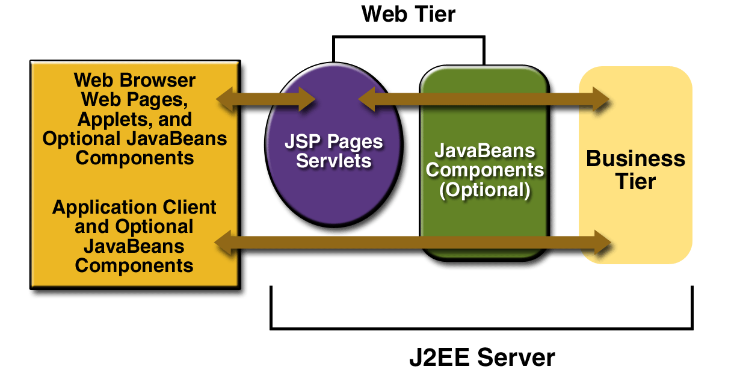

19

**Major Project Report** **Virtual Assistant**

**5.2 MySQL (Database)**

MySQL is an open-source relational database management system (RDBMS). Managing and creating tables is easy in MySQL . We have created five tables in the database namely registered_users , checkdocuments , seatallotment , vacantseats and final_list .

MySQL has helped us as it has good -

* Support for prepared statements.
* Support for multiple statements.
* Support for transactions.
* Enhance debugging support.
* More powerful functionality.

20

**Major Project Report** **Virtual Assistant**

**5.3 HTML**

HTML stands for Hyper Text Markup Language. It is the standard markup language for creating the web pages and web applications. HTML elements are the building blocks of html pages. HTML constructs such as interactive forms may be embedded into the rendered page. It provides images and other objects such as interactive forms may be embedded into rendered page. It provides a means to create structured documents by denoting structural semantics for text such as headings, paragraphs, lists, links, quotes and other items.

HTML with Cascading Style Sheets (CSS) makes our pages more interactive and HTML with JavaScript provides the dynamic functionality in static web pages . HTML ,CSS and JAVASCRIPT forms a triad of technology for the World Wide Web. HTML adds “look and feel” to our page

We have used HTML to create tables and forms in our jsp pages (verify.jsp). It provides us better user interface with the same functionality.

An HTML table is defined with the <table> tag and with the help of html <table> tag we can make our content more justified .<tr></tr> and <td></td> tags are used for creating rows and data cells. Tables and Forms can be nested either way. But if you put forms into tables, each form must be completely into a single table cell(one TD element). Different tags like <br/> tag ,<hr/><h1></h1> have been also used to provide a blank splace ,horizontal line and headings in web page.

21

**Major Project Report** **Virtual Assistant**

**5.4 CSS**

It is a style sheet language used for describing the presentation of a document written in markup language.

CSS describes how HTML elements are to be displayed on screen.  It can control the layout of multiple web pages all at once.

CSS is designed primarily to enable the separation of document content from document presentation, including features such as the layouts, colors and fonts.

 It is independent of HTML and this separation of HTML from CSS makes it easier to maintain sites, share style sheets across pages.

**Counselling Assistance** focuses on making the interface quite user-friendly andinteractive for the user whether it is Student or Counselling official. Hence in order to make the appearance of Java Server Pages, CSS is embedded along with HTML in order to enhance the appearance of web-page. Without CSS, Virtual Assistant would be much less appealing.

CSS is designed primarily to enable the separation of document content from document presentation, including aspects such as the layouts, colors and fonts. The separation can improve content accessibility provide more flexibility and control in specification of presentation characteristics enable multiple html pages to share formatting by specifying the relevant CSS in Separate files that can be linked.

***CSS is of three types:***

* **Inline CSS:** - To use inline styles, add the style attribute to the relevant element. The style attribute can contain any CSS property. Example-

<div style=”border: 1px solid red; background: white; color: red ;”> ABC</div>

* **Internal CSS**: Internal styles are defined within the <style> element, inside the <head> section of an HTML page. Example-

<head>

<style>

body {background: white; margin: 0px; padding: 0px;}

</style>

</head>

* **External CSS**: - External CSS is that CSS which is not in the document. It is written in another document with and then .css extension. The file should not contain any html tags. Eg:

<link rel ="stylesheet" href="css/style.css">

**5.5 JavaScript**

JavaScript runs on the client side of the web, which can be used to design / program how the web pages behave on the occurrence of an event. Alongside HTML and CSS, it is one of the three core technologies of World Wide Web content production.

The merits of using JavaScript are −

* **Less server interaction** − You can validate user input before sending the page off to the server. This saves server traffic, which means less load on your server.
* **Immediate feedback to the visitors** − They don't have to wait for a page reload to see if they have forgotten to enter something.
* **Increased interactivity** − You can create interfaces that react when the user hovers over them with a mouse or activates them via the keyboard.

Javascript HTML DOM(Document Object Model) helps to find and access HTML elements in an HTML page. With JS we can manipulate HTML elements. For this we need to find elements and this can be achieved using:

* Finding HTML elements by id
* Finding HTML elements by tag name
* Finding HTML elements by class name
* Finding HTML elements by CSS selectors

<p id="demo"></p>

<script>

var myElement = document.getElementById("intro");

document.getElementById("demo").innerHTML =

"The text from the intro paragraph is " + myElement.innerHTML;

</script>

23

**Major Project Report** **Virtual Assistant**

**5.6 Hibernate**

**Introduction:**

Persistent data can be seen anywhere in an application. Managing persistent data is one of the few challenges that modern technologies/products are facing. The Hibernate is used for the representation and conversion of data between the database and the object-oriented programming language .

**Object-Relational Mapping:**

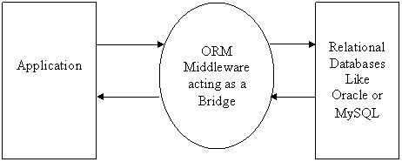

***Fig.1 Object Relational Mapping***

***ORM*** acting as a bridge between the application and the database As one infer from the above picture, application depends on the **ORM** for all the database-related services like persisting service (for saving the data), query service (for retrieving existing data from the database) and the ORM takes care of communicating with the appropriate database.

**In Hibernate we have created two packages (model.to and model.dao).In model.to we have created all the tables of our databases and in model.dao we have created two classes HbernateUtil.java &HibernateViewUtil.java in which we have made connection with database (MySql).and in other class we have made functions for inserting and fetching data from database.**

**Advantage Of hibernate**

* A well built object model can be useful in debugging.
* Hibernate is database independent Using hibernate we won't worry about writing database specific queries and syntax.
* It support annotations.
* It allows database management.

24

**Major Project Report** **Virtual Assistant**

25

**Major Project Report** **Virtual Assistant**

**Chapter-6**

**PROJECT DESCRIPTION**

This section explains all the details about **SPaRk-Virtual Assistant**. It throws light on all modules description, files & web-pages involved in the implementation of the project.

* 1. **Project Working**

The project working consist of various steps:-

1. **AIML Scripting**

First,We created the AIML file that only handles one pattern, load aiml b. When we enter the command to the bot, it will try to load basic_chat.aiml. It won't work unless we actually create it. Here is what you can put inside basic_chat.aiml. We will match two basic patterns and respond.

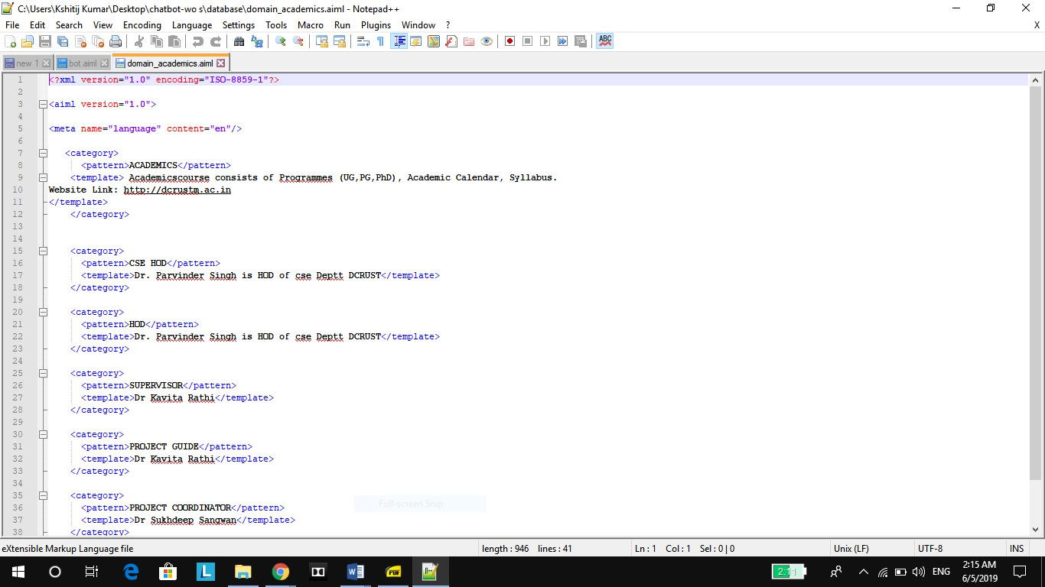

1. **Creating a Startup File**

It is standard to create a startup file called std-startup.xml as the main entry point for loading AIML files. In this case we will create a basic file that matches one pattern and takes one action. We want to match the pattern load aiml b, and have it load our aiml brain in response. We will create the basic_chat.aiml file in a minute.

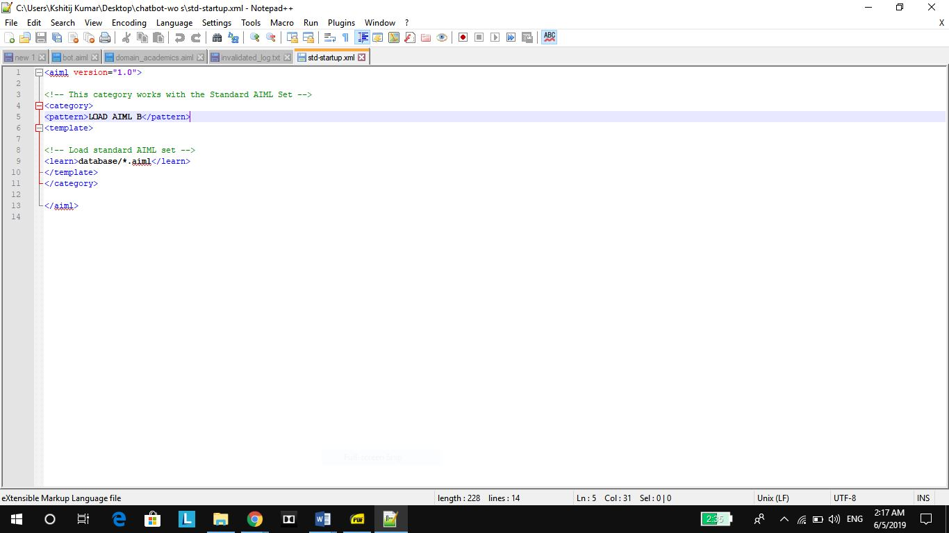

52

1. **Creating Interfaces**

The interfaces are the front end chat box for user to talk to the bot, which can be the Bot Portal, Skype, Facebook, etc.The connector works as a common gateway for all the interfaces. The outbound side calls different APIs to different front end, but the inbound APIs kept the same for our bot to connect. Fortunately, this connector has already been implemented by the bot framework SDK, we only need to rightly configure them. The botpart contains the main flow control of our project. It is responsible for redirect the input to different models, parse the return values, and determines what to do next. It is also connected to the database to retrieve and update values.

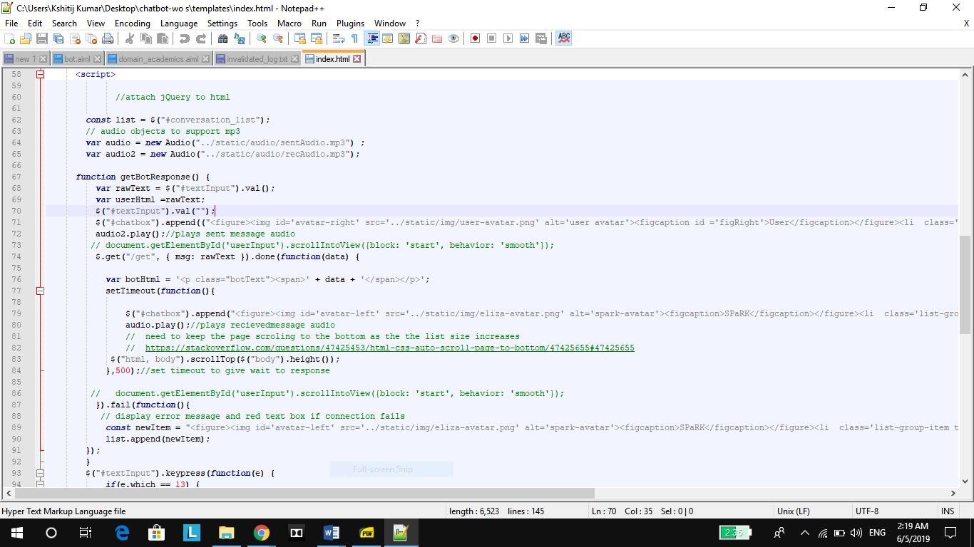

1. **Speeding Up Brain Load**

When you start to have a lot of AIML files, it can take a long time to learn. This is where brain files come in. After the bot learns all the AIML files it can save its brain directly to a file which will drastically speed up load times on subsequent runs.



**5.Loading Brain**

This is the simplest program we can start with. It creates the aiml object, learns the startup file, and then loads the rest of the aiml files. After that, it is ready to chat, and we enter an infinite loop that will continue to prompt the user for a message. You will need to enter a pattern the bot recognizes. The patterns recognized depend on what AIML files you loaded. We create the startup file as a separate entity so that we can add more aiml files to the bot later without having to modify any of the programs source code. We can just add more files to learn in the startup xml file.

**5.Creating Invalidated Log File**

The contents in log file are appended if chatbot get any query from user and and there is no response available in stored information in aiml file.then the chatbot generates a random response from available random responses and does an entry in log file.

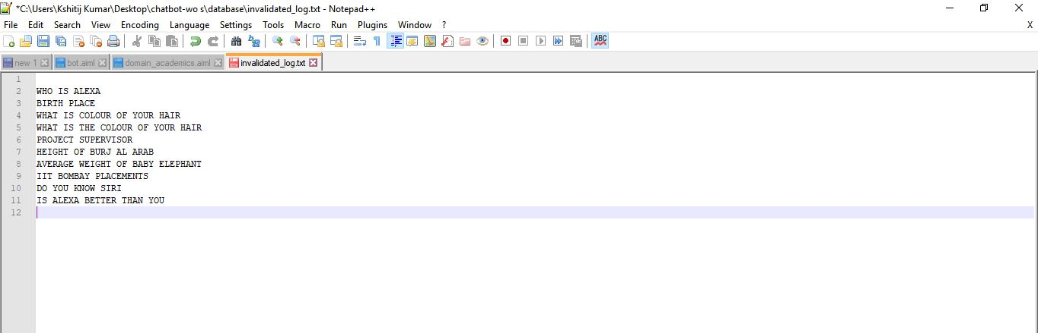

**6.Implementation**

This section covers the design and implementation of different module of the bot, which contains the design of the PYTHON module, the Translator API and the AIMLmodule.

main_with_session.py is the main file which is used for running the main program.It loads the AIML scripts and prepares the database for further implementation.The chatbot is implemented from this main file.

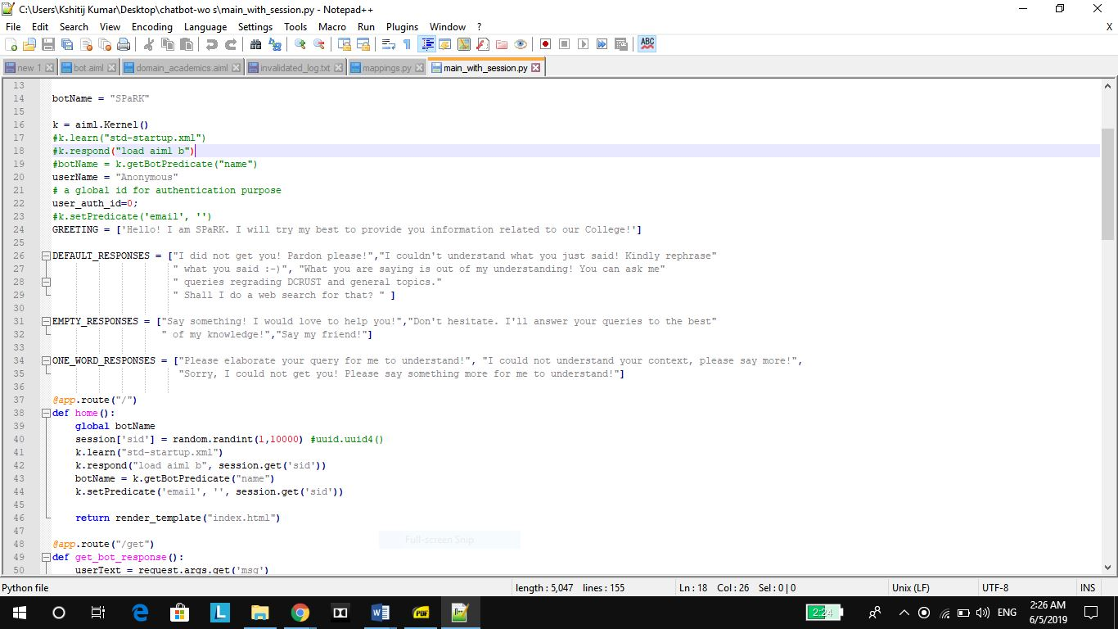

.

**Running main file to run Chatbot from cmd**

We run the main program from cmd using python main_program.This will load all the aiml files and also the database files which will help in smooth running of chatbot application(Virtual Assistant).

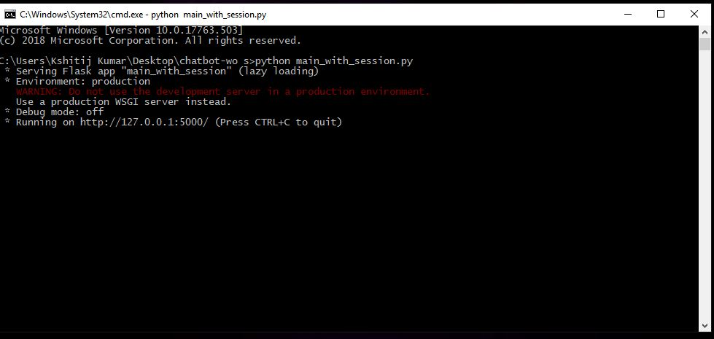

Invoking main program form cmd

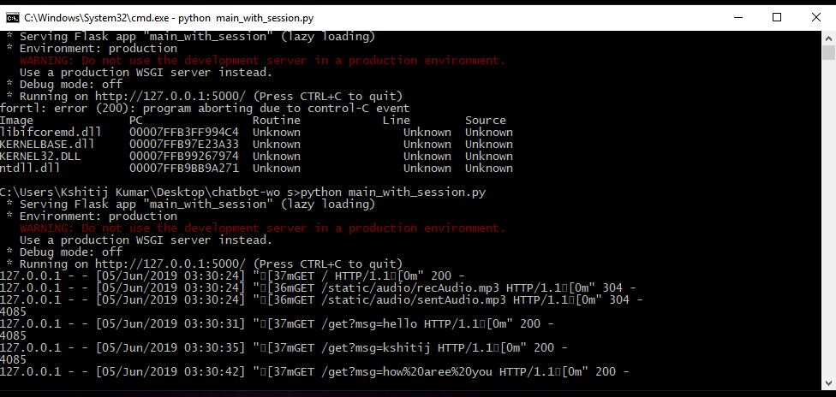

Backgroud Processing in cmd after processing is done in main chatbot screen.

**SCREENSHOTS**

Here are the screenshots of running Virtual assistant.as we can see that as user enter a query response is generated from information already stored in chatbot.Also,there is provision for entering a query by voise which uses google Speech to Text API which parses voice to a text type and produces response from database.

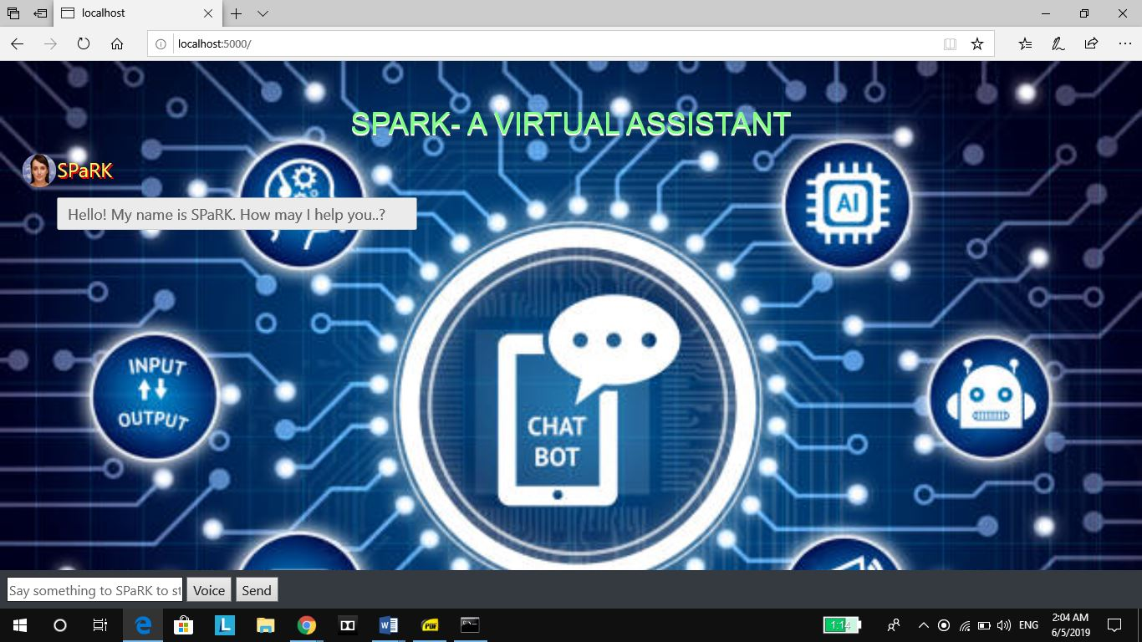

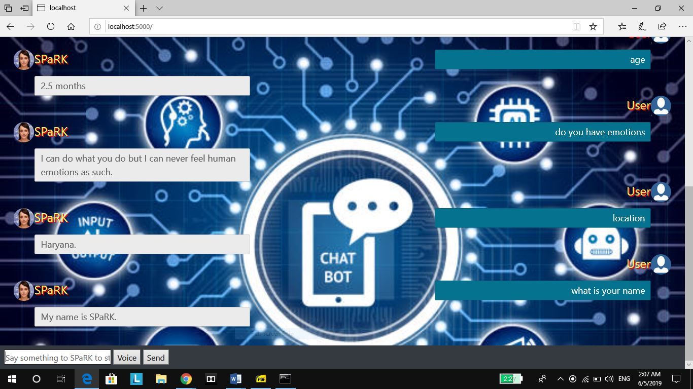

USER chat going on is shown in above screenshot.Here we have asked a number of queries for which virtual assistant is responding back.

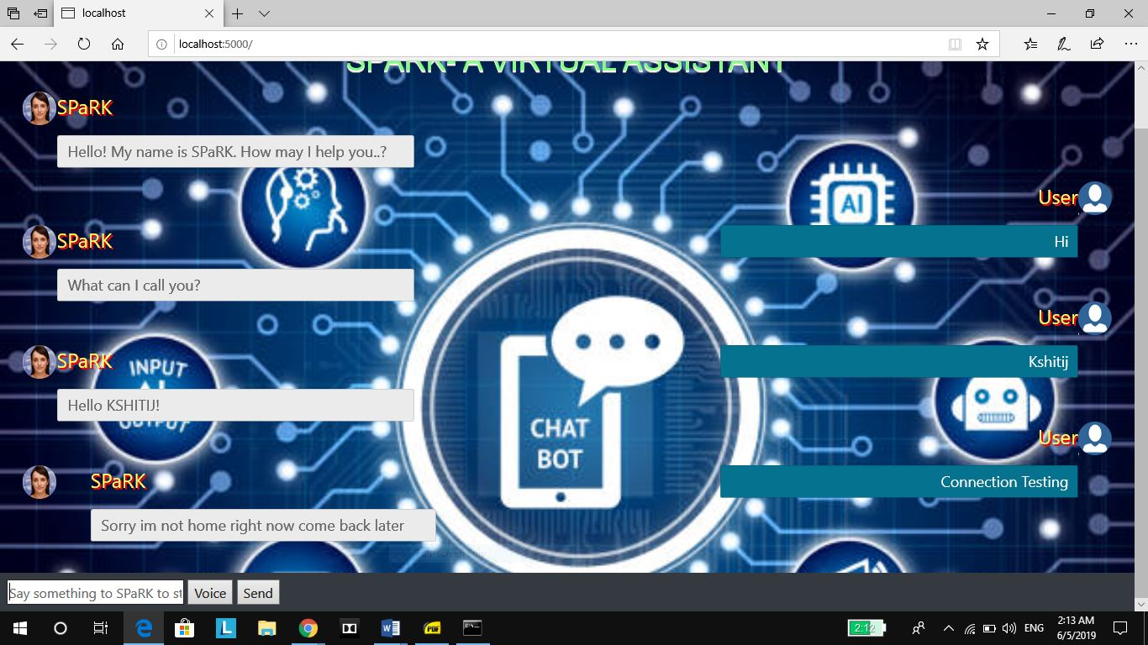

As we can see above that on typing a query when connection is lost Chatbot displays an error message Sorry I am not home right now come back later.This is an identification to the user that his connection has been lost and he needs to reconnect.

**6.2 Data Flow Diagrams**

This section will describe the data flow how Virtual Assistant works.

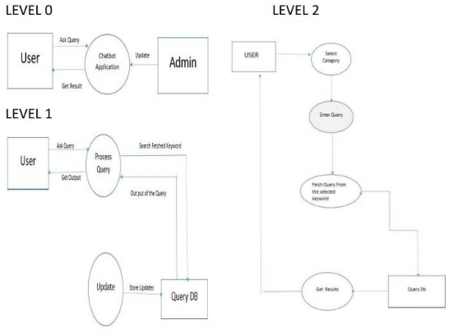



**Work Flow Diagram**

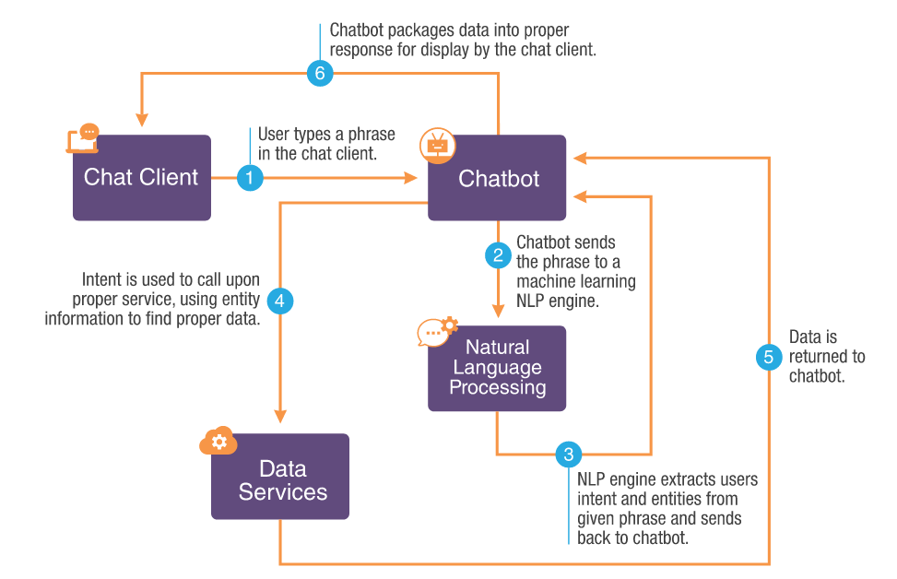106